**Experiment 5 :-**

**AIM:-** To apply built-in functions of SQL to analyze the university database.

**Description:-**  Built-in Functions in SQL statements, allowing you to perform operations on data right within the database itself.  Using database functions can significantly reduce the amount of data that needs to be retrieved from the database.

**BUILD-IN FUNCTIONS**

1. **UPPER:-** Converts a string into uppercase.

**Syntax:**- SELECT UPPER (NAME) FROM UNIVERSITY;

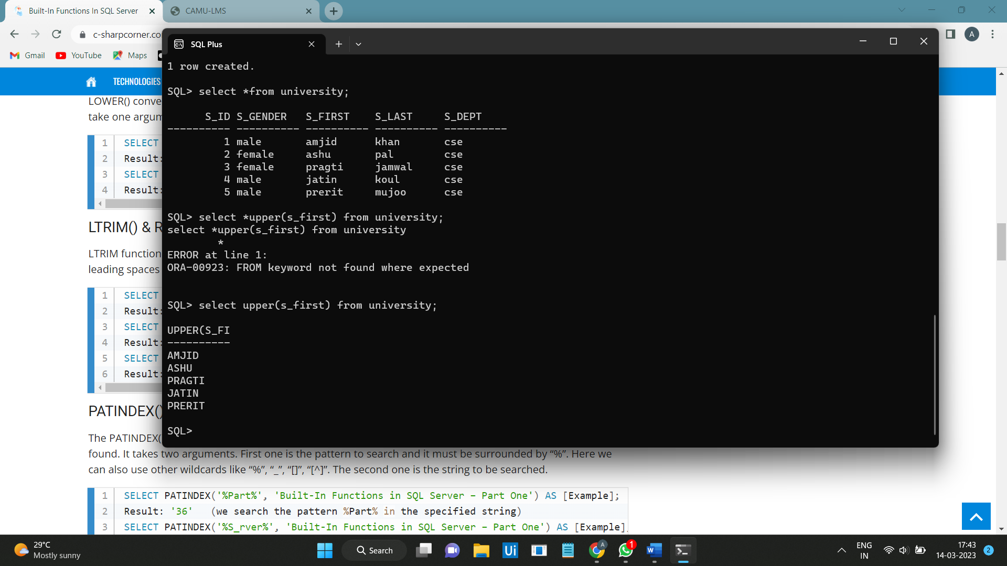

1. **LOWER** :- Converts a string into lowercase.

**Syntax**:- SELECT LOWER(NAME) FROM UNIVERSITY;

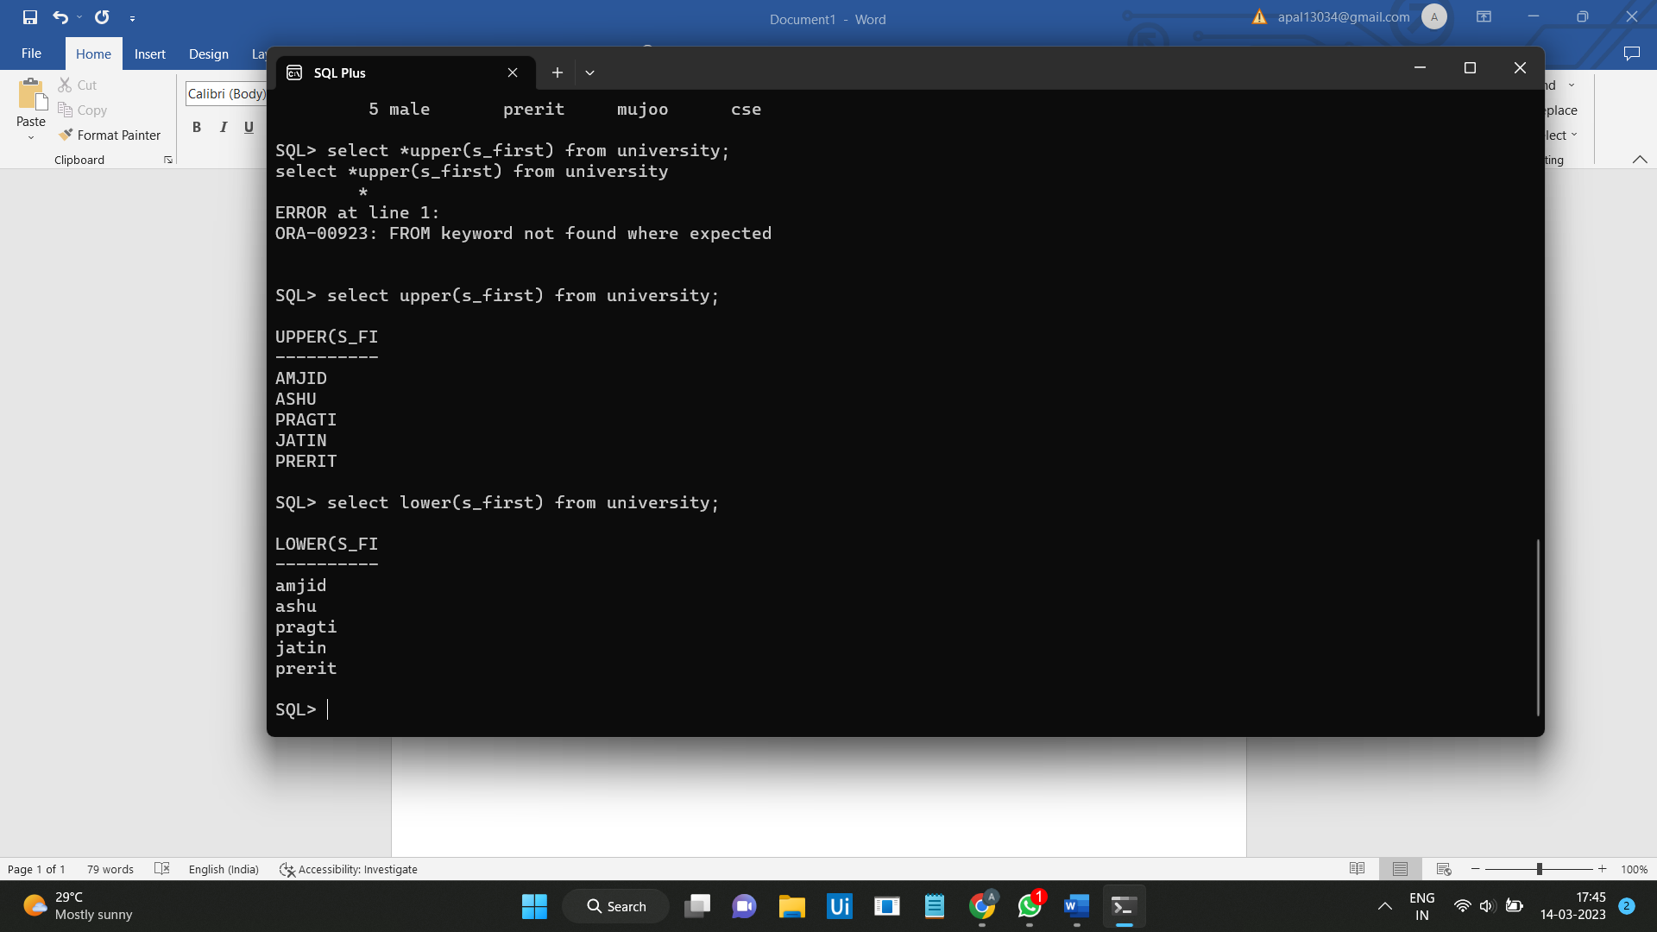

1. **LTRIM:**- LTRIM function removes all leading spaces from a string starting from left.

**Syntax:-** SELECT LTRIM(NAME) FROM UNIVERSITY;

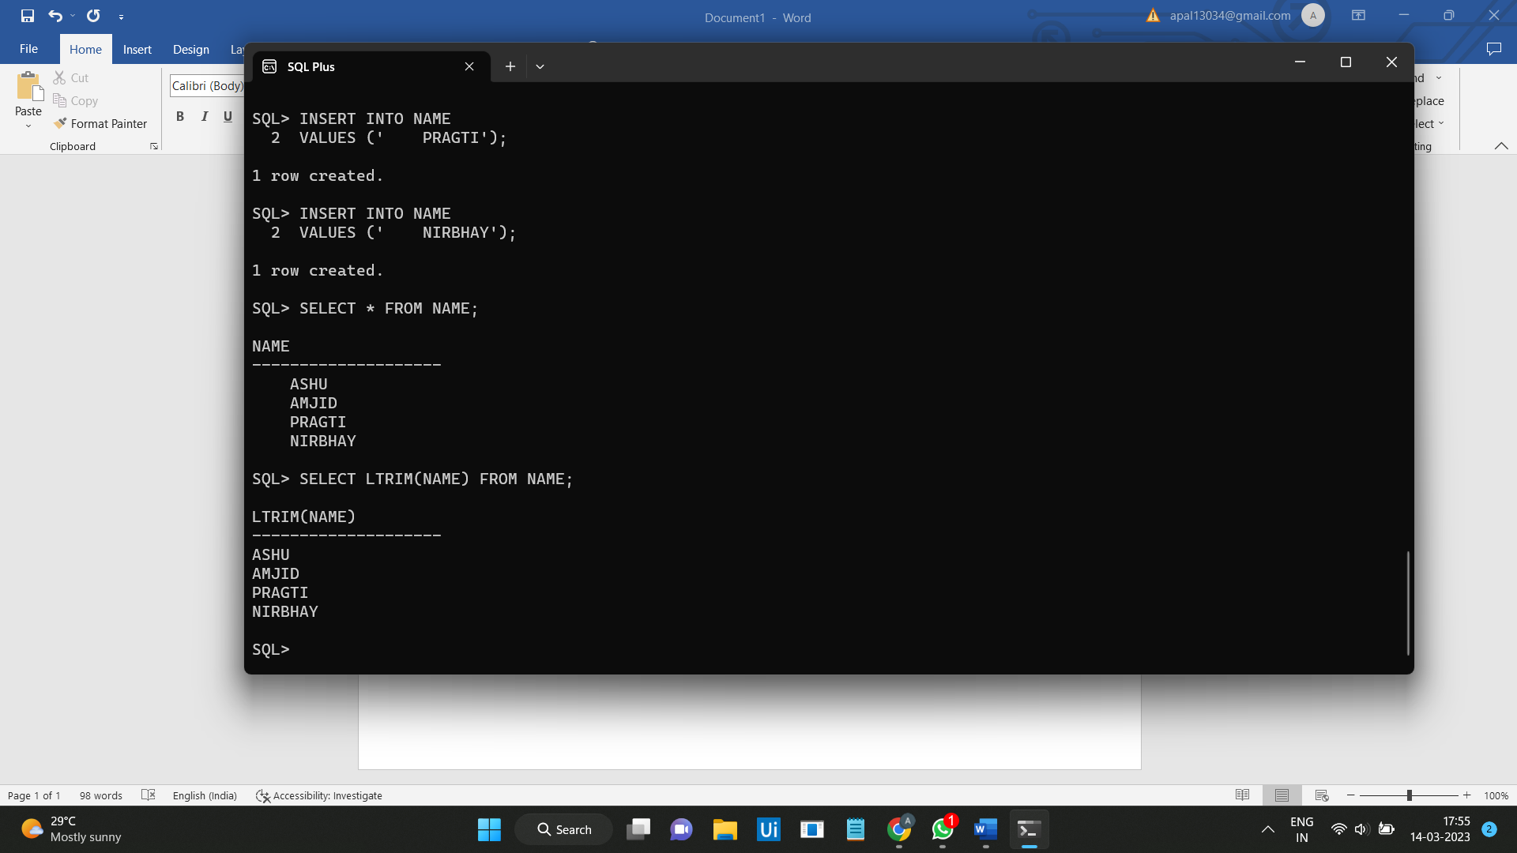

1. **RTRIM:-** RTRIM() function removes all leading spaces from a string from right.

**Syntax:-** SELECT RTRIM(NAME) FROM TABLE_NAME;

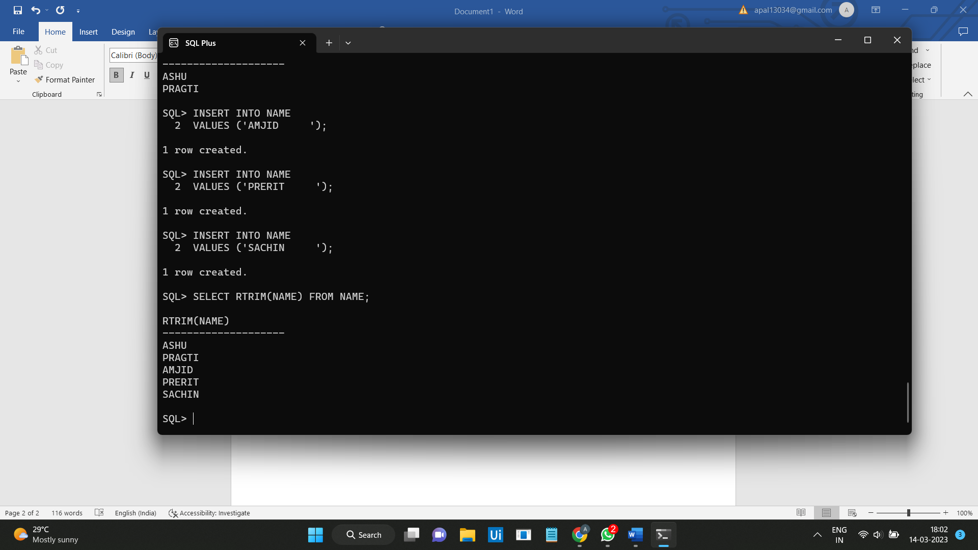

1. **INITCAP**:- INITCAP function is used to uppercase the first letter of string**.**

**Syntax:-** SELECT INITCAP(NAME) FROM TABLE_NAME;

